**D. Y. Patil College of College of Engineering and Technology, Kolhapur**

**Department of Computer Science & Engineering**

**Class: SY-A Subject: AOOC**

**Experiment no: 15**

**Group No. G 26 Mini Project**

**Title of Mini-Project:**

**Student average calculator**

**Group Members:**

|  |  |  |  |
| --- | --- | --- | --- |
| **Unique id** | **Roll No** | **Name of Student** | **Sign** |
| EN23235186 | 104 | Sneha Pandurang Bamane |  |
| EN23184486 | 120 | Pragati Shantilal Shendage |  |
| EN23198398 | 121 | Akshata Dattatray Malavi |  |
| EN23242857 | 122 | Sanika Govind Mane |  |
|  |  |  |  |

**Problem Statement:**

1. Manual Calculation Errors: Manual calculation of student percentages and grades can lead to errors, which can be time-consuming to identify and correct.

2. Time-Consuming Process: Calculating student percentages and grades manually can be a tedious and time-consuming process, taking away from other important tasks.

**Introduction:**

The Student average Calculator is a web application designed to simplify the process of calculating student results. It provides a user-friendly interface for inputting student information, including name, roll number, and marks for 3 subjects. The application automatically calculates the percentage and grade based on the marks entered, eliminating the need for manual calculations.

Key Features

1. Student Information Management: Input and store student information, including name, roll number, and marks for multiple subjects.

2. Automatic Percentage Calculation: Calculate percentages based on marks entered, reducing errors and saving time.

3. Grade Calculation: Determine grades based on predefined grading scales, ensuring consistency and accuracy.

4. Result Display: Display student results, including percentage and grade, in a clear and concise manner.

Benefits

1. Accuracy: Automated calculations reduce the likelihood of errors.

2. Efficiency: Streamlined process saves time and effort.

3. Transparency: Easy access to results promotes transparency and accountability.

4. Progress Tracking: Enables tracking of student progress, helping identify areas for

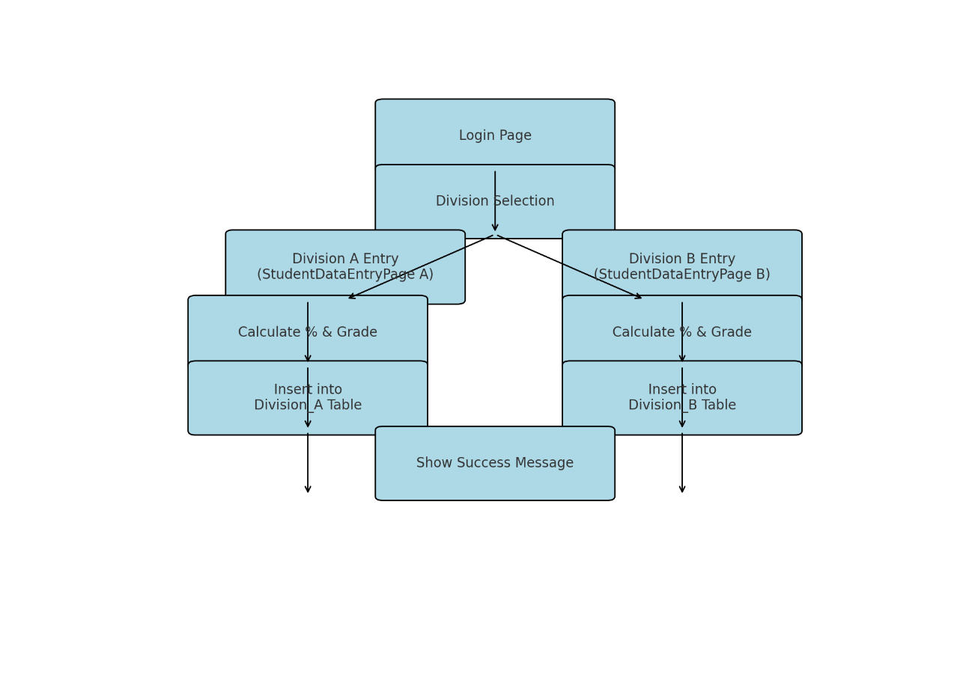**System Architecture:**

**Module description or working of system:**

1. Student Information Module

- Functionality: Allows users to input and store student information, including name, roll number, and marks for multiple subjects.

- Features:

- Input fields for student name, roll number, and marks

- Validation checks for ensuring accurate data entry

2. Calculation Module

- Functionality: Automatically calculates the percentage and grade based on the marks entered.

- Features:

- Percentage calculation based on total marks

- Grade calculation based on predefined grading scales

3. Result Display Module

- Functionality: Displays the student's result, including percentage and grade.

- Features:

- Clear and concise display of student results

- Option to print or save results

4. Data Storage Module

- Functionality: Stores student results securely, allowing for easy retrieval and tracking of student progress.

- Features:

- Secure data storage using a database

- Option to retrieve and view previous results

**🔄 System Working Flow**

1. User Accesses Website

- User launches the website and accesses the result calculator page.

- The website's GUI is displayed, allowing users to input student information.

2. Student Information Input

- User enters student information, including name, roll number, and marks for multiple subjects.

3. Calculation

- The system calculates the percentage and grade based on the marks entered.

- The calculation is performed automatically, reducing errors and saving time.

4. Result Display

- The system displays the student's result, including percentage and grade.

- The result is displayed in a clear and concise manner, making it easy to understand.

5. Result Storage (Optional)

- The system stores the student result securely, allowing for easy retrieval and tracking of student progress.

- The stored results can be used for future reference or analysis.

6. Output

- The user can view, print, or save the student result for their records.

- The system provides a convenient and reliable way to calculate and manage student results.

**Screenshots:**

